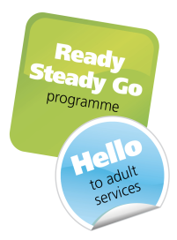

Ready Steady Go & Hello:

Ready Steady Go and Hello:

Delivering:

Patient empowerment,

Shared decision making,

Transition.

Monday 23rd March 2020
Lecture Theatre 1, South Academic Block,

University Hospitals Southampton NHS Foundation Trust, Southampton

Delivering 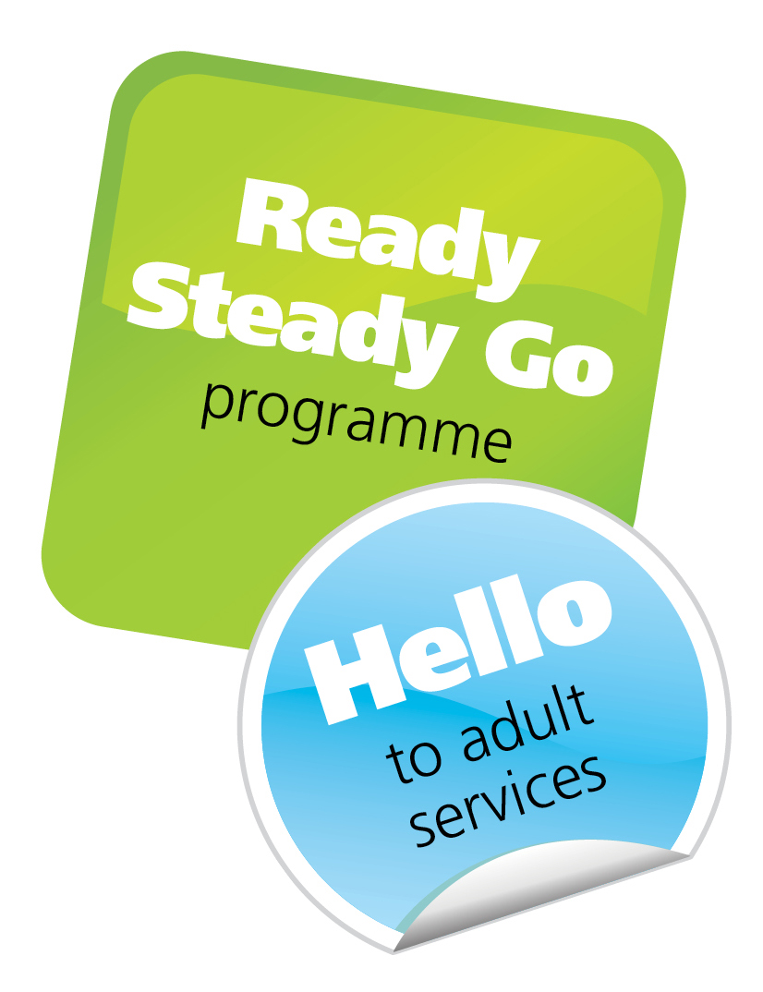

Patient empowerment, Shared decision making and transition

09:30– 10:00  10:00 – 10:05 | Registration  Welcome | Paula Head CEO
10:05 – 11:30 | ‘Creating the future together’  Ready Steady Go + My Medical Record: Delivering patient empowerment, shared decision making and transition | Kath Evans, Patient (TBC)  Arvind Nagra
11:30 – 11:50 | Coffee Break
11:50 – 13:10 | Attendee abstract presentations: Cases/Resources x 4
13:10 – 13:50 | Lunch
13:50 – 15:20 | Chair-  “The psychosocial impact of living with a long term condition  PEEER (Improving Patient Empowerment, self Esteem, Employability, & Resilience) project: to help address the psychosocial impact of living with a long term condition  Writing letters to patients: Empowering!  IT solutions: Patient owned electronic record ( My Medical Record) / centralised information resources/Virtual assistant | Kath Evans  Dr Alexander Hamilton  Sarah Shameti youth worker, Dr Arvind Nagra/  Dr Charlie Tomson/ Dr Ian Logan  Patient/Ade Byrne/Andrew Davis
15:20 -15:40 | Coffee Break
15:40 – 17:00 | “Lets talk about sex, baby“  Shared decision making and Personalised Care | Patients and Kate Wiles/Kath Evans  Professor Paul Roberts
17:00 | Close of meeting

Applied for 5 CPD credits from the Royal College of Paediatrics and Child Health

Cost of course (to include lunch and refreshments): £50

