How to Organise PREP Days on Zoom

Organising a PREP day
You will need to start organising the PREP day a couple of months in advance. For ideas on what to cover for each topic you can access the RCPCH curriculum. You can see timetables from previous PREP days on the timetables page for each PREP group, however you may be more easily be able to seek speakers DGHs in the region and from further afield now that days are hosted on Zoom.

All PREP days are recorded, with videos uploaded to a password protected area on the PIER site via embedded unlisted YouTube video (i.e., not searchable or accessible unless link shared with you). When inviting speakers, please confirm they give permission for their talk to be recorded; if they would like access to the video, please email Gen through wessexpaediatrictrainees@gmail.com and the link can be shared with the speaker. SIM and baliant sessions will not be recorded.

Uploading the Timetable
Please upload the timetable for your PREP day to the PIER site using the ‘Timetable Upload’ tab for relevant PREP group, at least one week prior to the day. The timetable will be visible a day or two after upload.
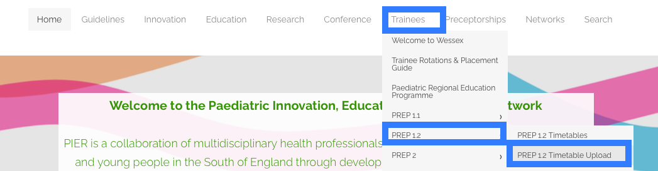

It is the responsibility of the trainee leads for each PREP group to update the timetable for the year with dates, topics and speakers; you will need to contact James Edelman (james.edeman@uhs.nhs.uk) to get access to Weebly, which will allow you to edit these pages on the PIER website. Whilst PREP days remain on Zoom, the link for the meeting will be added to the timetable for the year by Gen.

Registers and feedback
The trainee organising each PREP day must send the register for the day to the consultant lead for their PREP group, and feedback from the day. Whilst online you may find it easiest to use Google Forms or Survey Monkey to collect feedback.

Zoom Set-Up
The meeting links have already been set up for the year, and are available on the Timetable page for each PREP group. Trainees can access the link through the page, however it is recommended you send the link to any speakers. The password for each PREP meeting is ‘PREP1.1’; ‘PREP1.2’; ‘PREP2’; or ‘PREP3’ as appropriate- this is not displayed on the public page and you will need to inform speakers of the password.

The trainee leading the day will need to login as described above, then make themselves host to have access to the record function and breakout rooms:
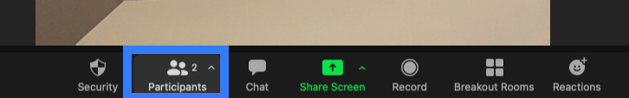
- Click on the ‘Participants’ icon.

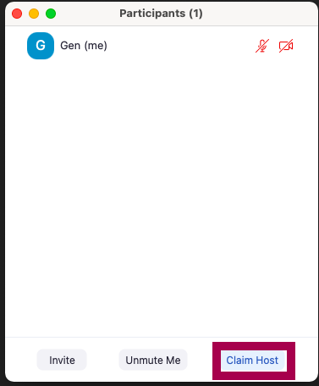
- Select ‘Claim Host’

- When prompted, enter the Host Key 050748 and click ‘Claim Host’
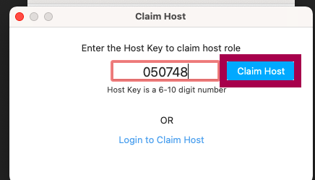

- You will then have additional options available to you on your Zoom screen, including the ‘Record’ button and breakout rooms.

Recording talks
To record, use the ‘Record’ button at the bottom of the screen, and select ‘Record to the Cloud’. This will save the recording to the PIER Zoom account.
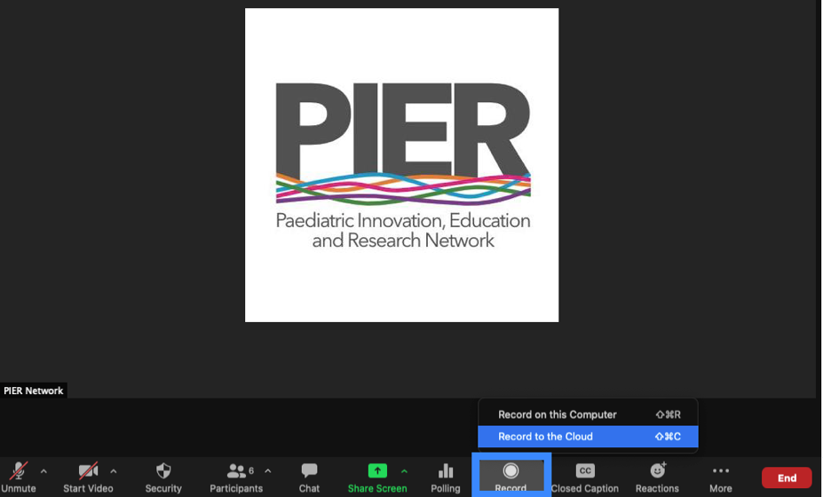

Please press ‘Stop’, not pause, at the end of each talk, so that each talk is saved as a separate video file to ease uploading the videos.

The pause function can be used if any part of the talk is not appropriate to be recorded.

Videos will NOT be edited, therefore please be conscious to pause or stop the recording if anything is not appropriate to be recorded

If you have any questions relating to these technical aspects of the PREP days, please email Gen through wessexpaediatrictrainees@gmail.com. Your trainee and consultant leads for each PREP group remain the point of contact for queries regarding the content of PREP itself (contact details on the PREP pages on PIER).

