Organising a PREP day

PREP 6/7 days are organised by the trainees for the trainee, so your engagement is essential for this to continue to be a successful programme, it is expected that each trainee will take part in organising at least one day during their ST6-8 years. This is also an excellent opportunity for your eportfolio (organising teaching at a regional level) and could be utilised for leader CBD.

We endeavour to help trainees link their PREP day to the PROGRESS+ curriculum; this will be signposted to the organising trainee in advance.

Arranging Speakers:
If you are allocated to plan a day, please contact potential speakers 5-6 months in advance. Do not underestimate how much advanced warning people require. Potential speakers could be suggested by the trainee lead based on previous days in past years, or by the lead consultant depending on the subject you are covering. Please do use your initiative and discuss with local consultants, and not just those in Southampton, as there is a huge wealth of experience available across the region, including specialist nurses, allied health professionals and non-clinical personnel working in healthcare.

Speakers could also join virtually if attending in person was not possible, or if you wish to invite experts from outside the region.

Uploading the Timetable:
Please upload the timetable for your PREP day to the PIER site using the ‘Timetable Upload’ tab for relevant PREP group, at least one week prior to the day. The timetable will be visible a day or two after upload.
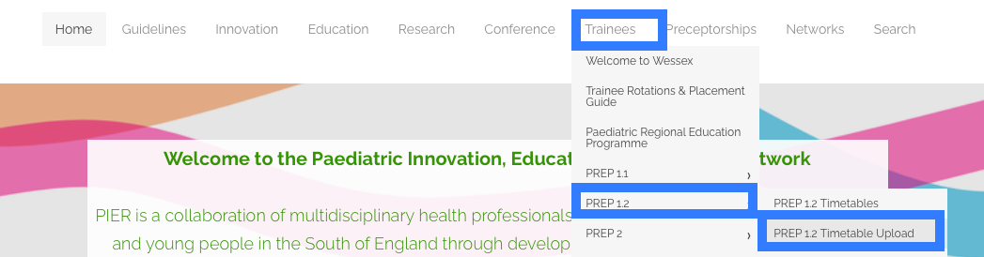

The PREP 6/7 trainee lead can also email the programme on your behalf to all trainees. Please feel free to also share this on the ST6-8 WhatsApp group.

Room booking:
Sim suite is usually booked in advance by the trainee lead for PREP6/7, as SIM sessions can only be held there. Non-SIM days can be hosted in seminar/ lecture facilities at any of the hospitals in the region and this allows utilising different experiences across the regions. Please do let Dr Kate Pryde know if you wish to organise this (funding can be provided by the deanery).

Lunch/Parking:
Funding is now available for Lunch, please liaise with the PREP 6/7 trainee lead for more details.
Discount for parking at UHS is available, contact travelwise@uhs.nhs.uk for details on how to arrange this. Trainees who are not based at UHS will need to park in the visitor’s carpark to use a discounted ticket.

https://www.uhs.nhs.uk/Media/UHS-website-2019/Docs/Maps/Patient-and-visitor-parking-map-UHS.pdf

Registers and feedback:
The trainee organising each PREP day must send the register for the day to the consultant lead for their PREP group, and feedback from the day. I have attached the link for a google sheet which we are using as the register for this academic year.

https://docs.google.com/spreadsheets/d/1HmV1ceOa6W3s2id-jyxIiv4ZIItRJ3rgUi4b94_c1qc/edit?usp=sharing

I have also created a google form for you to collect feedback. Please tailor it according to your day. It is the organising trainee’s responsibility to collate this, and then send back to both the trainee and consultant PREP leads.

https://docs.google.com/forms/d/e/1FAIpQLSehWO9FIDp8jq2O-N-mG9RUSjnB40LF3Y1LTl_pfiKS-NVXMA/viewform?usp=sharing

It is a good practice to ask the speakers in advance if they wish to receive a copy of the feedback when you initially approach them.

Your trainee and consultant leads for each PREP group remain the point of contact for queries regarding the content of PREP itself (contact details on the PREP pages on PIER).

